Day 4 Assignment

0)Mail servers of ibm.com and wipro.com using nslookup command in cmd (windows system)

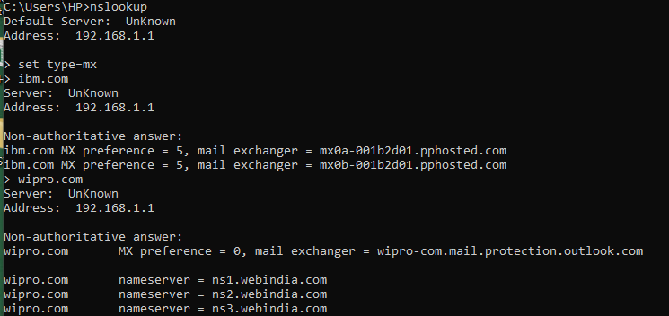

1. The open ports of the given ip address are

